Pacific Marine and Industrial  P.O. Box 70520  Richmond, California, United States  94801  IMPORTANT: READ THIS MANUAL FOR RECOMMENDED CLEANERS, AND PRIOR TO INSTALLATION, OPERATION, OR MAINTENANCE  Installation and Operation  Manual for  Bilge Boy™ 7.5 gpm (1.9 m³ / hour)  Oil / Water Separator  Model Numbers:  BB00811DXX (115 VAC/ 1 Phase / 50 or 60 Hz)  BB00822DXX (230 VAC/ 1 Phase / 50 or 60 Hz)  Protected by U.S.A. PATENT 4,608,160 and  CANADIAN PATENT 1,274,784 | 1 | GENERAL INFORMATION
 | 2 | SYSTEM OVERVIEW
 | 3 | INSTALLATION AND START-UP
 | 4 | MAINTENANCE / TROUBLE SHOOTING
 | 5 | COMPONENT DATA

TABLE OF CONTENTS

TJGLJGL;G;IG;IG;IG;IG;IG;IG;IGI;G

Section | Page Number
1.0 General Information  1.1 Purpose and Scope  1.2 Precautions Definitions  1.3 Abbreviations and Acronym List  1.4 Detergent / Cleaner Use  - List of approved cleaners  - Product Warranty | 5
- System Overview  - General  - Functional  - Gravity Separator  - Coalescer  - Oil Removal  - Coalescer Element and Differential Pressure Gauge  - Specifications | 11
3.0 Installation and Start-up  3.1 Mechanical Installation  3.2 Electrical Installation  3.3 Before Start  3.4 Start-up and Operation  3.4.1 Coalescer Element Change-out  3.4.2 Remote switch operation | 19
4.0 Maintenance  4.1 Maintenance  4.2 Long Term Storage  - Troubleshooting  - Replacement Parts List | 27
5.0 Component Data | 39
LIST OF FIGURES

Figure Number and Description | Page Number
- Bilge Boy™ 7.5 gpm Oil / Water Separator | 12
- Gravity Separator | 13
- Coalescer Housing | 14
- System Flow Paths | 16
- Component Identification | 17
- Installation Plumbing Guide | 20
- Installation Area Recommended | 21
- Control Panel Circuit Board– Layout | 23
- Circuit Board Electrical Schematic | 24

- General Information

  - Purpose and Scope

This manual describes and explains the installation, operation, functioning, maintenance, and trouble shooting of the Bilge Boy™ 7.5 gpm unit, model numbers BB00811DXX and BB00822DXX.

  - Precaution Definitions

WARNING: Identifies a practice or procedure, if followed incorrectly, has the potential to be life threatening or cause serious bodily injury.

CAUTION: Identifies a practice or procedure that the operator must observe to prevent damage or destruction of equipment, or failure to maintain water quality.

NOTE: Identifies a procedure or condition that requires additional information or explanation.

  - Abbreviations and Acronym List

AMPS = amperes  Cm = centimeters  dP = differential pressure  F = fuse  ft = feet  ft² = square feet  gal = gallons  GPM or gpm =gallons per minute  Hr = hour  ID = inside diameter  Kg = kilograms  kPa = kilopascal  L = liters  LBS or lbs = pounds  LPM = liters per minute  m = meters | m² = square meters  m³/hr = cubic meters per hour  mm = millimeter  mmHg = millimeters of mercury  OD = outside diameter  OWS = oil/water separator  PSI or psi = pounds per square inch  PSID or psid = pounds per square  inch differential  SW2 = PC Board switch #2  T = terminal  VAC = voltage of alternating current  VDC = voltage of direct current  " = inches  "Hg = inches of mercury

  - Detergent / Cleaner Use

CAUTION: For proper performance of the Bilge Boy Oil / Water Separator only specified detergents and cleaners can be used. Use of other brands or types can cause high separator effluent oil concentrations. In general, detergent use must be minimized.

Oil separation performance is heavily dependent on the size and chemical stability of the oil drops present in the water. Larger, less stable drops are easier to separate.

Certain engine degreasers and bilge cleaners can be used without causing significant adverse effects on the Bilge Boy™. Most solvent cleaners containing no detergent compounds will not affect the separator performance. These include organic solvents such as #2 fuel oil.

Detergents, defined here as surfactant containing formulations, generally cause the drops to be smaller, more stable and more difficult to separate. The type of detergent, its concentration, and the degree of scrubbing, determine cleaning effectiveness. Unfortunately many cleaners and degreasers create smaller, stable drops that are difficult to separate. NOTE: Do not use cleaners that are emulsifiers or contain high surfactant formulations.

Cleaning Recommendations:

- Use the minimal amount of cleaner with a maximum amount of water.

- Use high pressure hot water and / or low pressure steam whenever possible. Use the recommended cleaners whenever possible. Electric parts and motors can be cleaned with appropriate solvents. Rust can be removed with acidic solvents.

- Use the ship's motion to assist in cleaning when possible. Rinse with an excess of water after use.

- Spray-on / wipe-off cleaners (Formula 409, Fantastic, Simple Green, Super Clean, or the equivalent) may be used ONLY if they DO NOT enter the bilge.

- Monitor the discharge water closely to determine the effect cleaning operations may have on the separator's performance. Modify the cleaning procedures appropriately.
1.4.1 List of Approved Cleaners

- CLEANERS

Spic & Span
Proctor & Gambel
PO Box 599
Cincinnati OH 45201

Phone: (800) 801-1767

Drew Ameroid OWS
Ashland Chemical Corp
1 Drew Chemical Plaza
Boonton, NJ 07005 USA

Phone: (800) 526-1015

Nalco # 2865
Nalco Chemical Co.
Water Gy Division
1 Nalco Center
Napierville IL 60563 USA
Phone: (800) 477-3025

NOTE: This listing does not imply that these are the only acceptable cleaners for use with the Bilge Boy™ system, we do not sell or endorse cleaners. Other cleaners may be tried in small amounts to determine if they adversely affect the separation performance of the Bilge Boy™. If they do not in the small amount, the amount of the trial cleaner may be increased to that normally used, then assess its affects on performance.

- NEUTRALIZERS

Household White Vinegar

- DEODERIZERS

Household Ammonia (non-detergent)

  - Product Warranty

For a period of one (1) year from date of delivery, Bilge Boy. (Seller) engineered products are warranted to be free from defects in materials and workmanship when properly installed, maintained, and operated within the specified working parameters for which the equipment was designed. If the engineered product does not perform as warranted, it will be repaired or replaced, at the Seller’s discretion, free of charge, including Parts and Labor.

This warranty does not apply to consumable components such as Filter Elements, lamp bulbs, etc. This warranty shall not apply to product altered by anyone other than Seller or their representatives.

Seller shall not be responsible or liable for downtime, loss of income, living expenses, or other incidental or consequential damages that might arise out of the use of this property. This Warranty is the sole warranty made by Bilge boy in regards to this equipment. Bilge boy makes no other warranties, either express or implied, or of mechantability or fitness for a particular purpose.
- System Overview

  - General

The Bilge Boy™ 7.5 gpm is a two-stage gravity separator / coalescer type bilge oil / water separator (see figure 1). It is designed and fabricated to effectively remove oil from bilge water.

The system operates at a maximum of 7.5 gpm (1.9 m³ / hr). It may be used with or without oil content monitors / alarms and remote bilge switches (see MARPOL 73 / 78 for specific requirements). This system does not require the use of chemicals or additives. Specific detergents and cleaners, at limited concentrations, may be used for engine room and bilge cleaning operations with the water that is to be processed by this equipment.

  - Functional

    - Gravity Separator

The first stage of the system is the gravity separator (see figure 2). Water is drawn into the unit by suction from either the main or oil pump. The gravity separator is where most of the oil is removed from the water, and where the oil collects to be pumped to a holding tank. Large oil drops rise to the top of the housing, due to the lighter density of the oil. Smaller oil drops flow down and out at the bottom with the water. From the gravity separator outlet, the water and oil flow through the main pump and into the coalescer housing at the bottom.

    - Coalescer

The coalescer is the second stage (see figure 3). The water and oil flow inside-out through the element. The oil drops are captured by the element, while the water flows through the outlet to be discharged overboard. The oil caught in the element collects, or coalesces, with other oil as it moves toward the outside of the element. On the outside layer of the element the oil grows into drops. The oil drops grow until large enough to release from the element. When the drops release, they rise to the top of the coalescer housing.
Figure 1. Bilge Boy™ 7.5 gpm Oil / Water Separator
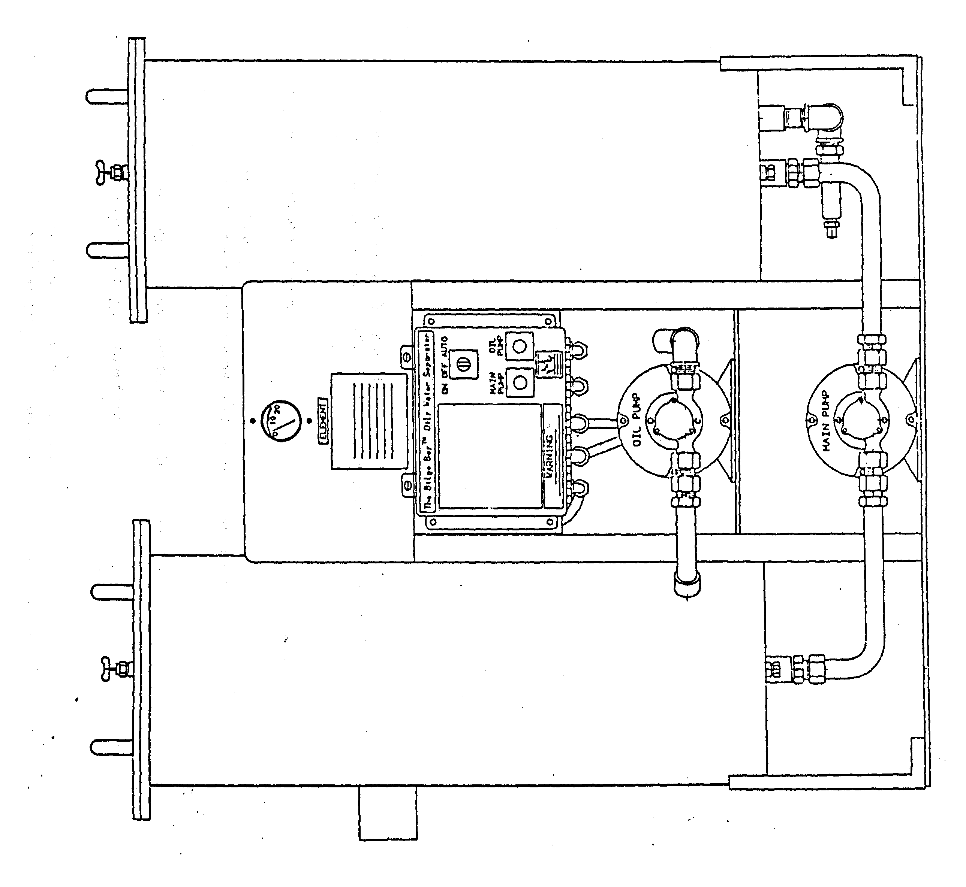
Figure 2. Gravity Separator Housing
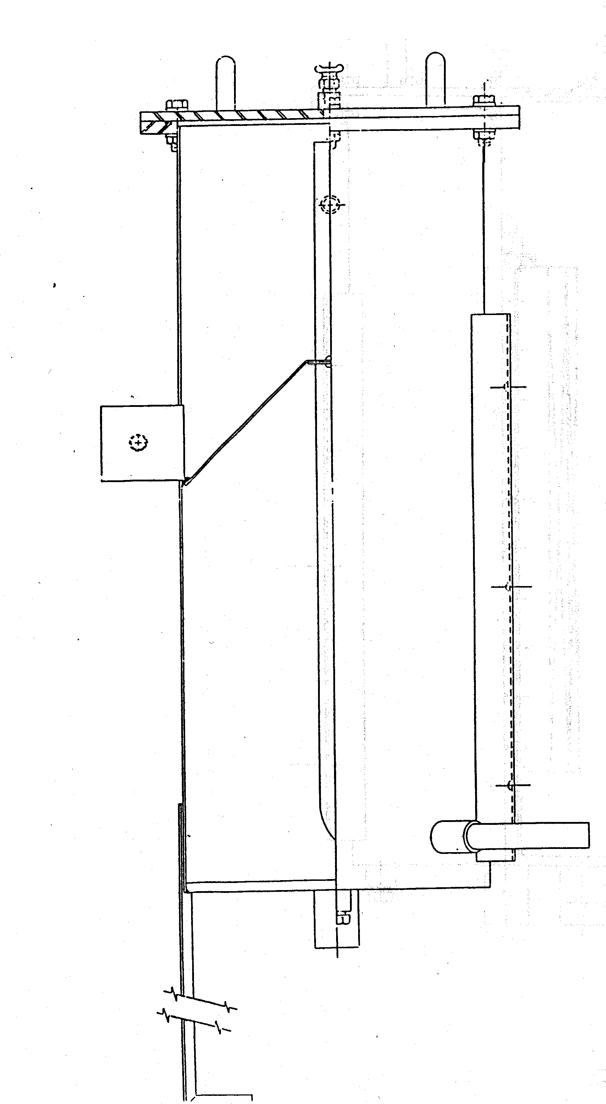
Figure 3. Coalescer Housing

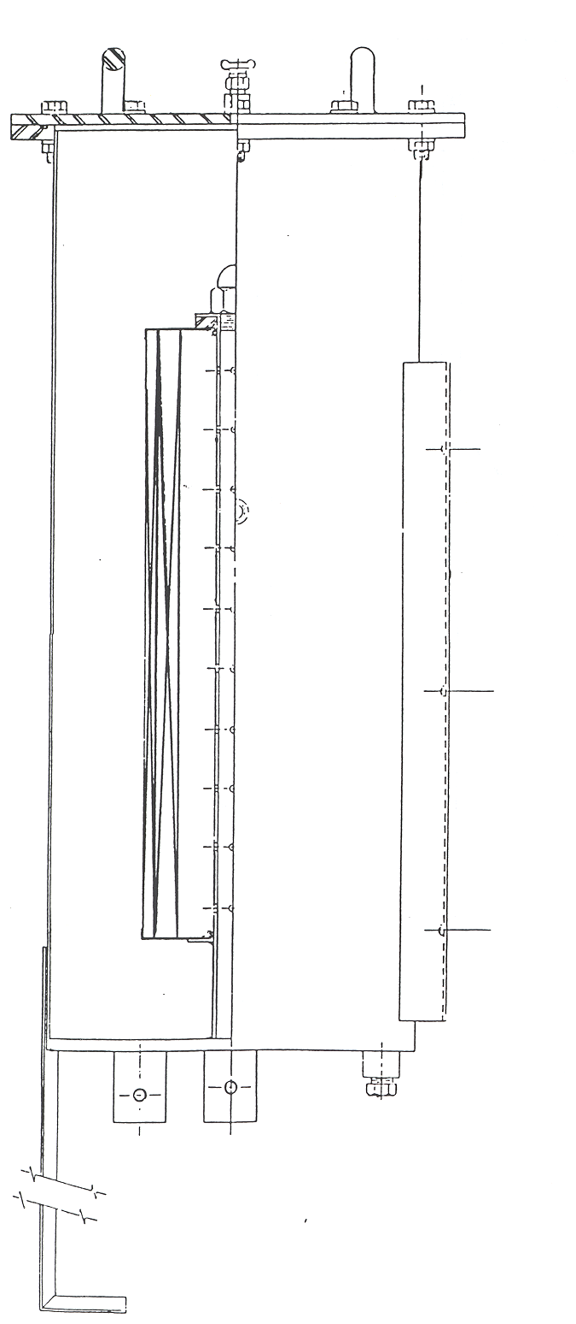
    - Oil Removal

The difference in pressure between the gravity separator and the coalescer housings produces flow through the 0.95 cm (0.38 inch) OD Oil Return Tubing (see figure 4). Oil collecting at the top of the coalescer housing flows through the return tubing to the inlet of the gravity separator. A metering valve controls the flow to about 0.4 LPM (0.1 gpm). Water also flows through the return tubing and helps keep the tubing free flowing. The oil returned to the gravity separator inlet is of a drop size that will separate from the water and collect at the top of the gravity separator housing.

When about 6 L (1.5 gal) of oil has collected in the gravity separator, it will cover the oil detector probe. When the oil detector senses a 50% or higher concentration of oil, it will send a signal to the control panel. The controls stop the main pump and start the oil pump. The oil is removed from the top of the gravity separator and pumped to the ship's waste oil holding tank. After about 12 seconds the oil is removed, the pumps switch back again, and the system continues processing water through the separator.

NOTE: Air in the gravity separator is detected as oil by the probe. Prolonged "dry" operation of the oil pump will cause damage to the oil pump impeller.

    - Coalescer Element and Differential Pressure Gauge

Water and oil can pass through the coalescer element. Dirt and other solid contaminants in the oil and water get trapped. In time the dirt will clog the element to the point where it will not coalesce oil properly. This is when the element needs to be replaced. A differential pressure gauge measures the clogging of the element. A gauge reading of 69 kPa (10 psid) or more indicates that the element should be replaced. A red line has been added to clearly indicate pressure above 69 kPa (10 psid).

NOTE: Read the gauge only when the main pump is operating.

The differential pressure gauge includes a switch that can be used to indicate when the element should be changed. The 120 VAC 4 amp (3 amp 30 VDC inductive) rated switch is pre-set to close a set of contacts at 10 psid. See the electrical section for wiring information.
Figure 4. System Flow Paths

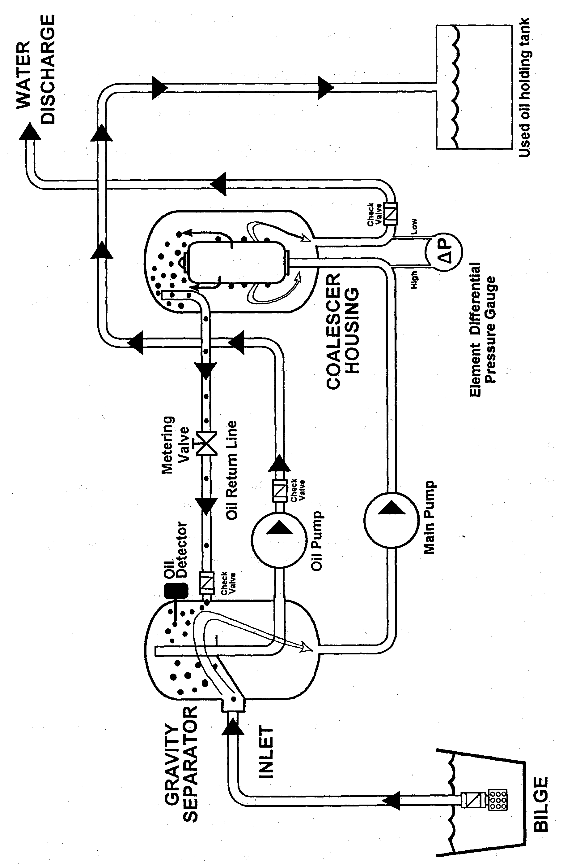
Figure 5. Component Identification

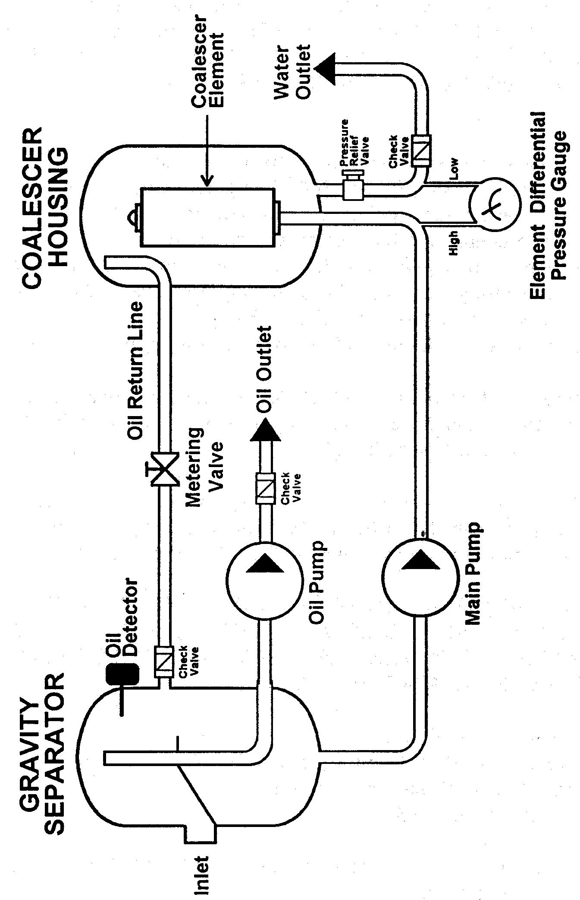
  - Specifications

MAXIMUM FLOW RATE: 7.5 gpm (1.9 m³ / hr)

SEPARATOR TYPE: Two Stage - Gravity Separator / Coalescer

DIMENSIONS:

45 inch (114 cm) HEIGHT

45 inch (114 cm) WIDTH

30 inch (76 cm) DEPTH

INLET: 2 inch NPT

OUTLETS: 1 inch NPT

WEIGHT: 300 lbs (140 Kg) DRY
550 lbs (250 Kg) WET

CAPACITY: 30 Gallons (114 Liters) TOTAL
15 Gallons (57 Liters) EACH HOUSING

OPERATING PRESSURES: RELIEF VALVE SET AT 15 psig (104 kPa)

GRAVITY SEPARATOR: 12 inch Hg (304 mm Hg) Maximum Vacuum

GRAVITY SEPARATOR HOUSING HYDROSTATIC TEST: 150 psig

COALESCER ELEMENT: 10 PSID (69 kPa Differential)

COALESCER HOUSING HYDROSTATIC TEST: 150 psig

ELECTRICAL:

Model BB00811DXX: 6 AMPS @ 115 VAC / 1 Phase / 50 or 60 Hertz

Model BB00822DXX: 5 AMPS @ 230 VAC / 1 Phase / 50 or 60 Hertz
- INSTALLATION

WARNING: Installation MUST be done by qualified personnel [46CFR 110.15-160], following accepted plumbing and electrical practices. Read the complete Installation Section prior to installation. Unsuitable installation can result in improper operation, component damage, and potentially hazardous conditions. Make certain ALL Installation Steps are completed correctly. THIS PRODUCT IS NOT TO BE INSTALLED IN HAZARDOUS LOCATIONS AS DEFINED IN THE US COAST GUARD ELECTRICAL ENGINEERING REGULATIONS.

WARNING: Motors can spark. Explosion & death can occur. Do not use where flammable vapors are present. Not to be installed in hazardous locations as defined in the US Coast Guard Electrical Engineering Regulations
[46CFR 111.80-5(a)(8) to (10)].

  - Mechanical

1) Identify all of the system components and check for possible damage or missing components. (see figure 5) Using figures 6 & 7 as guides, install the OWS using 5 cm (2 inch) ID or larger non-collapsible hose or pipe on the inlet and 2.5 cm (1 inch) ID or larger non-collapsible hose or pipe at the outlets.

2) Allow as much room as possible for solids to collect under the inlet without entering the system. Be very sure the inlet plumbing is air tight. An air leak into the plumbing may damage or destroy the oil pump impeller.

3) Install a suitable strainer and a foot valve (check valve) on the inlet piping.

NOTE: It is recommended that unions be installed as close as possible to the check valves on the water and oil discharge lines. An air leak is not as noticeable as a liquid leak. Carefully check all inlet piping.

CAUTION: Both the oil & water discharge plumbing should include a vertical section at least as high as the top of the OWS. This is necessary to help prevent siphoning and provide a slight back pressure to assist sealing of the check valves.

CAUTION: Some types of engine coolant rust inhibitors, anti-freezes, and low temperatures may cause damage to the pump impellers.
Figure 6. Installation Plumbing Guide

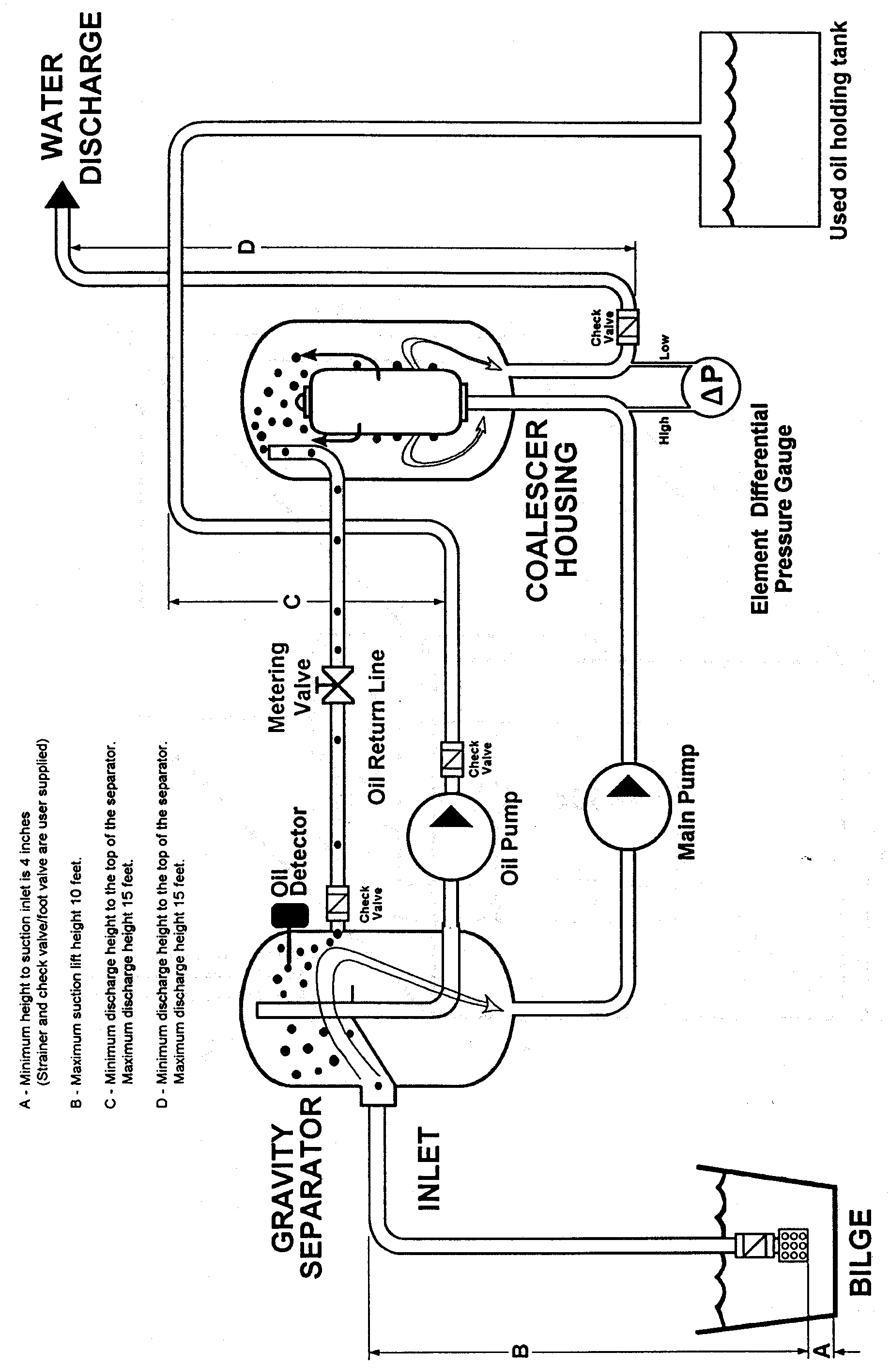
Figure 7. Installation Area Recommendation
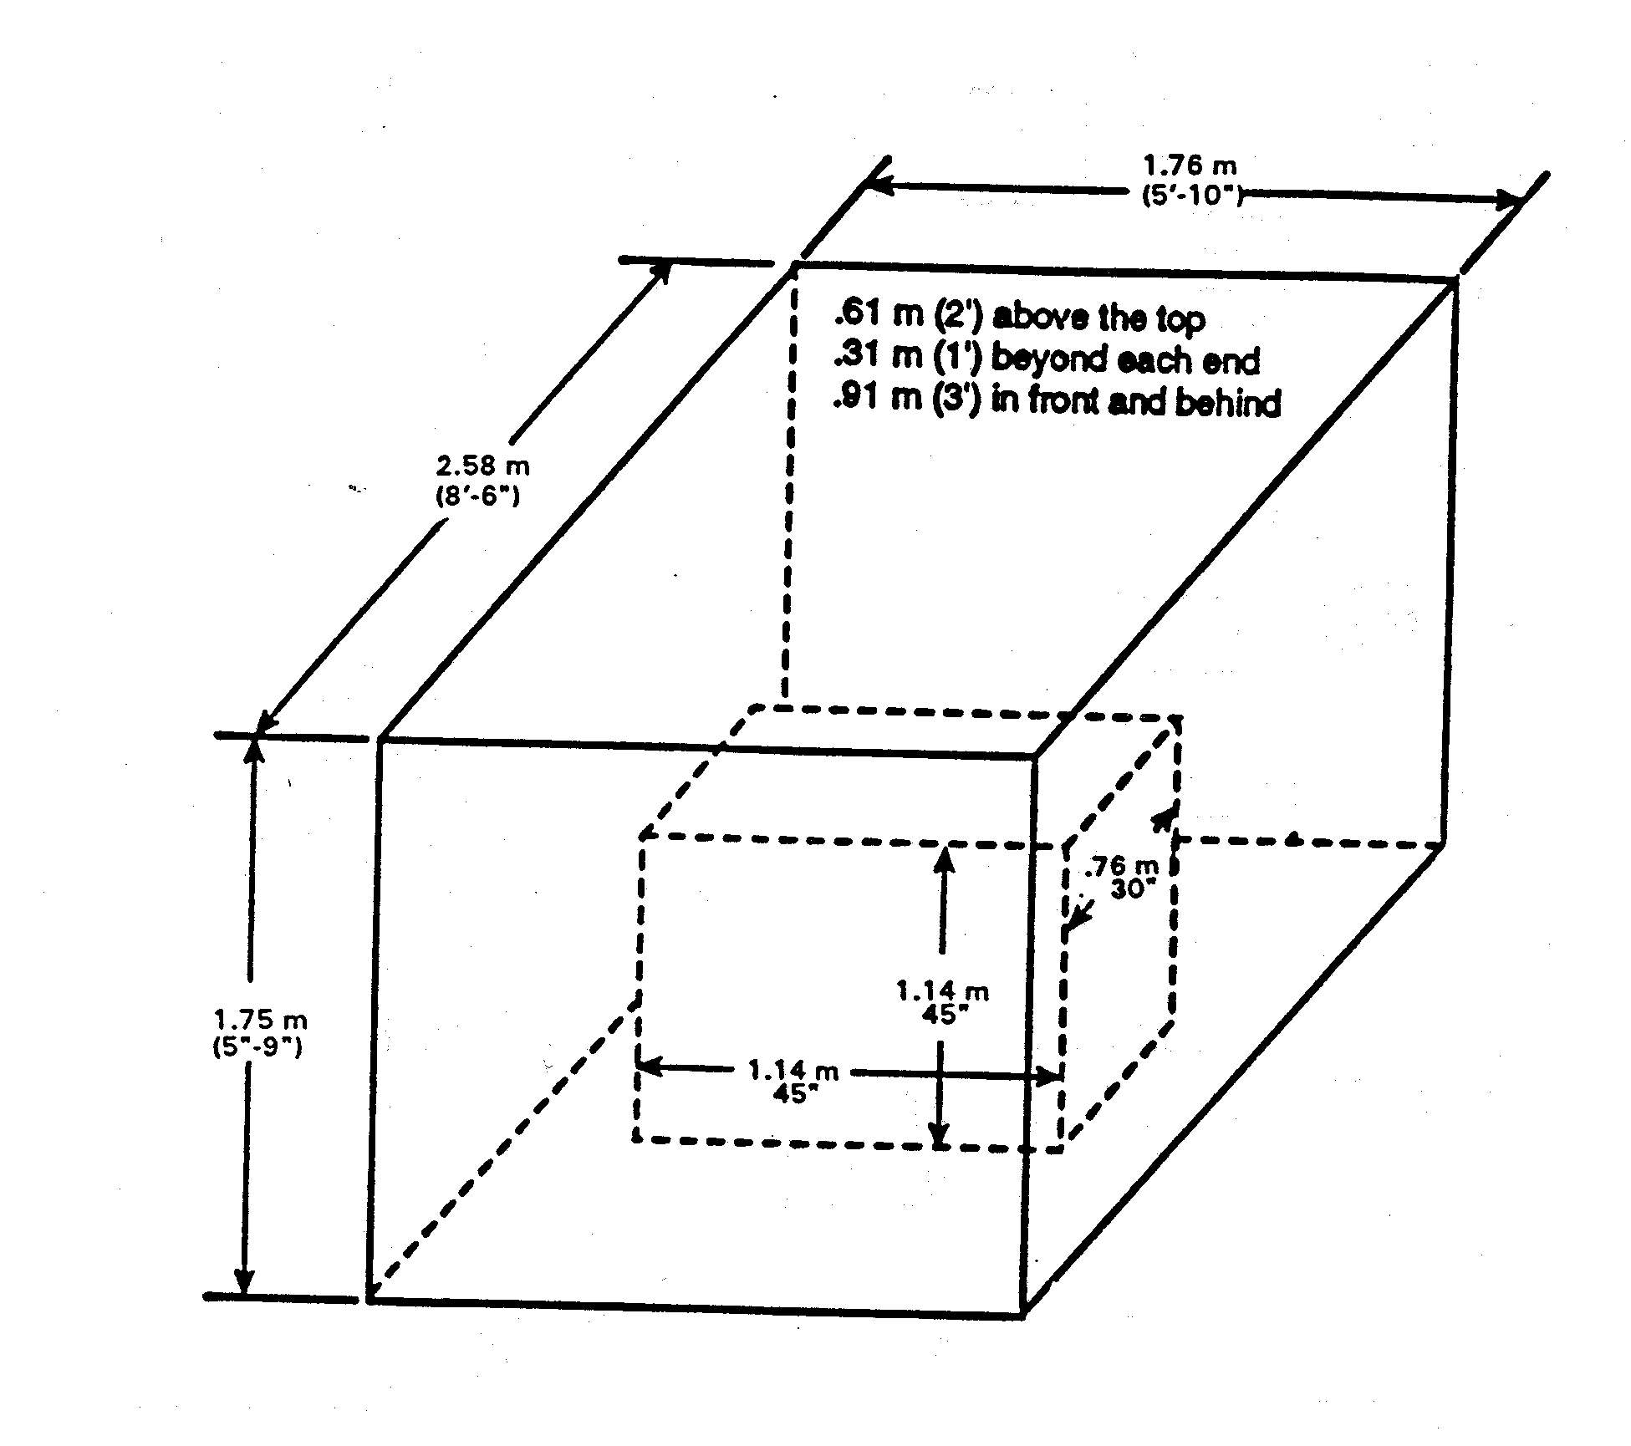

  - Electrical

WARNING: ELECTRICAL INSTALLATION AND CONNECTIONS ARE TO BE MADE ONLY BY QUALIFIED PERSONS. FOLLOW ALL APPLICABLE CODES AND PRACTICES. HAZARDOUS VOLTAGES ARE USED. DISCONNECT POWER AT THE SOURCE BEFORE PERFORMING ANY SERVICE.


3.2.1 Oil / Water Separator Electrical Connections:

Model BB00811DXX:

- Connect "HOT" 115 VAC lead to T13 FOR MANUAL "HAND" OPERATION.
- Connect "HOT" 115 VAC lead from the bilge level control switch to T18 FOR REMOTE SWITCH "AUTO" OPERATION.
- Connect "NEUTRAL" 115 VAC lead to T14 or T17.
- Connect "GROUND" to T15 or T16.

Model BB00822DXX:

- Connect "HOT" 230 VAC lead to T13 FOR MANUAL "HAND" OPERATION.
- Connect "HOT" 230 VAC lead from the bilge level control switch to T18 FOR REMOTE SWITCH "AUTO" OPERATION.
- Connect "NEUTRAL" 230 VAC lead to T14 or T17.
- Connect "GROUND" to T15 or T16.

3.2.2 Differential Pressure Gauge / Switch Connections:

- The red wire is wired to the normally closed contact.
- The black wire is wired to the normally open contact.
- The white wire is wired to the common contact.

Contact rating: 4 amperes at 120 VAC (3 amp at 30 VDC) inductive. The wire leads are 12 inches long, 18 AWG.

3.2.3 Oil Content Monitor Connections:

NOTE: A remote switch (Oil Content Monitor or Bilge Alarm relay contacts) may be connected to the control panel to stop the system when high oil concentrations are detected. Connect the normally open (overboard) relay contacts to T5 & T6. When high oil levels are detected (alarm mode) and the switch contacts close, the separator's alarm relay (K3) is activated. This will disconnect power to both pumps.
Figure 8. Control Panel Circuit Board - Layout

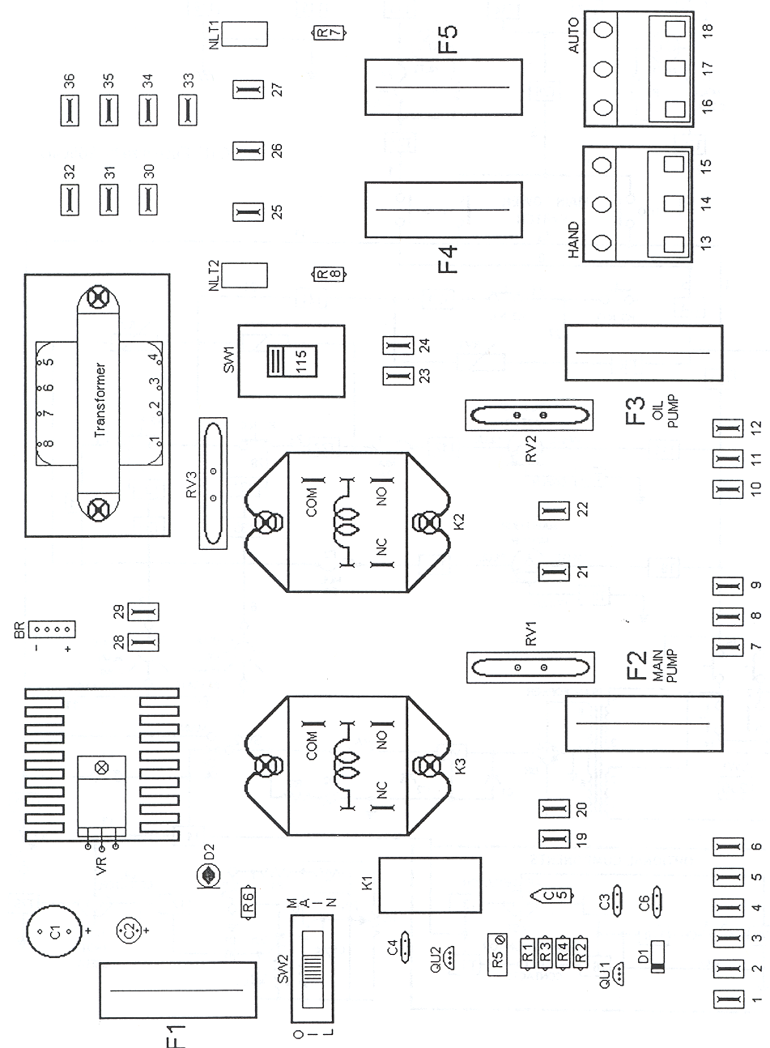
Figure 9. Circuit Board Electrical Schematic

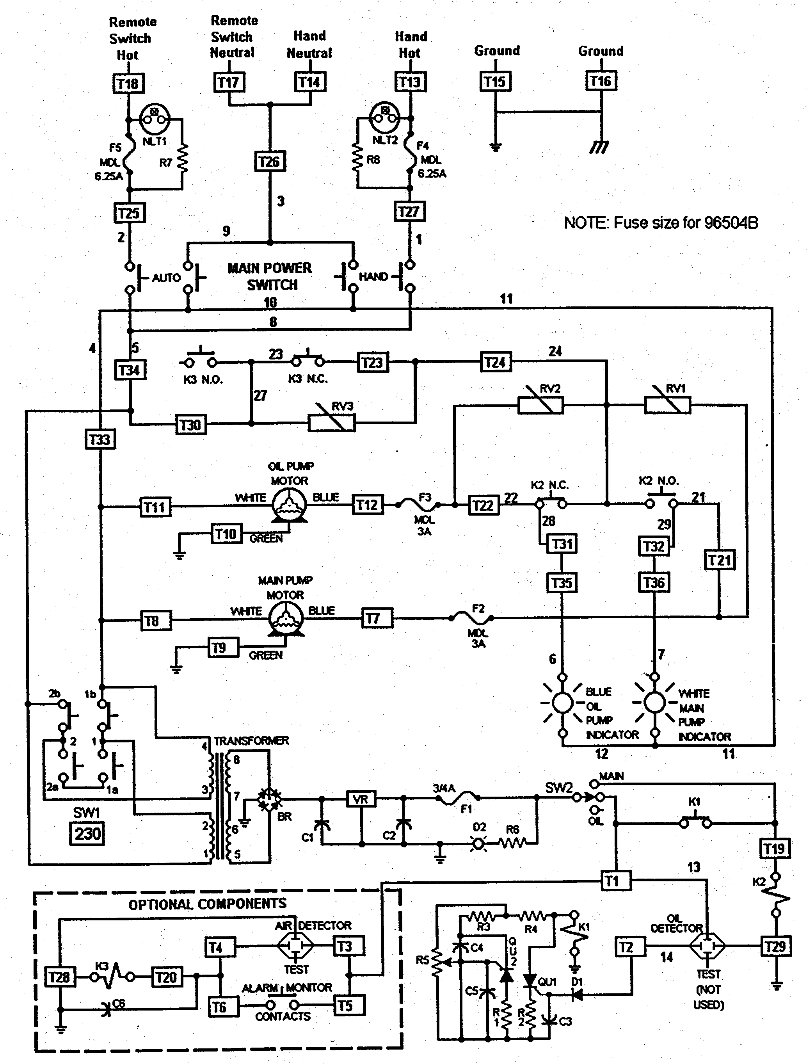

  - Before Start-Up

- Be sure the main switch is "OFF" with the electrical power disconnected from the source.

- Recheck the electrical connections and all plumbing to be sure they are correct.

- Check Circuit Board to ensure Switch SW2 is in the center position.

- Fill both Gravity Separator and Coalescing Housings, and all inlet plumbing with water.

- Open the Oil Return Line Metering Valve 1 turn counter-clockwise from fully closed.

CAUTION: A closed Oil Return Line Metering Valve is unsuitable because oil will fill the Coalescer Housing and be discharged with the water. Open the Oil Return Line Metering Valve more when the bilge water contains mostly lube or other viscous oils. Opening the Oil Return Line Metering Valve more than suggested 1 turn does not affect the separator performance, but it will reduce the water flow slightly.

- Check all fittings, nuts, bolts, vents, and covers for tightness.

- Be sure the supply tank has enough water in it so that air will not be drawn into the system.

  - Start-Up

- Apply power to the system and turn the main switch to "HAND". The oil pump will run first for about 12 seconds. The blue indicator light on the control panel should confirm the oil pump operation.

CAUTION: If the system has air in the inlet plumbing or gravity separator, the oil pump impeller may be damaged if run dry for more than 30 seconds.

- After about 12 seconds the oil pump should stop and the main pump will start. The white indicator light will confirm the main pump operation.

NOTE: If the oil pump operates initially for more than 12 seconds, or frequently when little or no oil is present, air may be entering the system. Turn the main switch to "OFF". Check for air leaks and refill the gravity separator if necessary. See the trouble shooting section for testing procedures.
  - Changing the Coalescer Element

- Turn the main switch to "OFF" and disconnect the power at the source.

- Open the Coalescer Housing drain plug at the bottom of the housing and drain the water into a container. NOTE: Opening the cover vent will speed draining. About 60 L (15 gallons) will drain.

- Remove the cover, the element nut & washer, and the rubber spacer.

- Remove the element by lifting it straight up.

CAUTION: Be careful not to damage the 0.95 cm (0.38") OD oil return tubing inside the Coalescer Housing.

- Wipe out all the oil off the inside of the housing.

- Install a new element (either end up).

- Reinstall the drain plug, spacer, washer and nut.

- Hand tighten the element nut.

- NOTE: A 3 mm (0.13") space is common between the element nut and washer.

- Fill the housing with water.

- Replace the cover, tighten the cover clamp and close the cover vent.

  - Remote Switch Automatic Operation

For automatic operation using a remote switch (ie: bilge level control switch) when connected as indicated in the "Electrical Installation" instructions, turn the main switch to the AUTO position.

- MAINTENANCE

  - Maintenance

Once every 6 months clean the oil detector probe. Change the oil coalescer element every 6 months or as indicated by the differential pressure gauge.

  - Long Term Storage (4 weeks or more)

- Turn the main switch to "OFF" and disconnect the power supply at the source.

- Drain all fluids completely from the system. This includes the all plumbing to the inlet, outlet, and waste oil holding tank.

- Open and wipe clean both housings.

- Remove and discard the coalescer element.

- Open the oil return metering valve fully (counter-clockwise) and apply slight air pressure to the coalescer end of the oil return tubing. This will clear the tubing of oil, water and debris.

WARNING: DO NOT USE EXCESSIVE AIR PRESSURE. WEAR EYE AND OTHER PERSONAL PROTECTION TO PROTECT FROM FLYING DEBRIS.

- Loosen the pump covers and drain the pump cavity.

- Lightly lubricate the pump impellers. This prevents damage to the impeller during the next start up. A silicone type lubricant is recommended.

- Replace the pump gaskets and covers, and tighten.

- Replace the housing gaskets, covers and clamps.
SYMPTOM | PROBABLE CAUSE | CORRECTIVE ACTION
Oil Pump "ON" More than  12 seconds  (Bilge has little or no oil in the water) | Incorrect Oil Pump Run Time | A. Turn Main Switch to "OFF" and disconnect the power at the source.  B. Remove the oil detector mating plug. (Lift tab and pull straight away.)  C. By-pass the oil detector by placing a jumper wire between the terminals of the mating plug. (See figure 11.)  D. Remove Fuse 2 & Fuse 3.  CAUTION: Do not permit jumper wire to short to Ground, or Fuse 1 will open.  NOTE: Removing Fuse 2 & Fuse 3 will allow the control circuitry & lights to be checked without the pumps operating. Replace the fuses when the tests and adjustments are complete.  E. Adjust the delay time by turning the slotted potentiometer screw (R5), counter-clockwise to decrease the time delay. (Clockwise to increase.) [30 revolutions maximum.]  F. Reapply power and turn the main switch to "HAND". The blue oil pump indicator should light for about 12 seconds, and then the white main pump indicator should light.  G. Repeat steps ‘a', ‘e & ‘f' above until the oil pump operation time is 12 seconds.  NOTE: This procedure will also test the wire harness and control circuitry.

SYMPTOM | PROBABLE CAUSE | CORRECTIVE ACTION
Oil Pump "ON" More than  12 seconds  (Bilge has little or no oil in the water) | Faulty Oil Detector | - Turn Main Switch to "OFF" and disconnect the power at the source.  - Remove Fuse 2 & Fuse 3.  - Fill the gravity separator with water. Leave the cover off.  - Reapply power and turn the main switch to "HAND". The blue oil pump indicator should light for about 12 seconds, and then the white main pump indicator should light.  - If this does not happen follow ‘A' above, check Fuse 1 and the wiring harness connections. Call Separation Technologies or your local distributor if you cannot get past this point.  - With the white indicator on, drain the water from the gravity separator. When the level reaches the oil detector probe the blue indicator should light.
 | Air Leak in Inlet Plumbing and / or Gravity Separator. | NOTE: The bilge must have a sufficient volume of water to operate, so that air cannot enter the system.  - Turn Main Switch to "OFF" and disconnect the power at the source.  - Disconnect the plumbing after the oil pump discharge plumbing after the check valve and place an adequately sized container under the plumbing to catch any oil or water.  - Reapply power, and turn the main switch to "HAND". Oil or water should come out of the oil discharge plumbing. Stop the system after 12 seconds if nothing, except air, comes out.  - Repeat ‘A' above, then check the gravity separator to be sure it is completely full of water. If it is not full, fill it. Check the oil drain tube, in the center, to be sure it is full of fluid. Also check the cover and cover gasket for dents or cracks when reinstalling them. Replace the cover and repeat step ‘c' above. If the condition does not change check the inlet plumbing for leaks.  NOTE: An air leak is not as noticeable as a liquid leak. Carefully check all inlet piping. Check the tightness of the inlet piping.

SYMPTOM | PROBABLE CAUSE | CORRECTIVE ACTION
Oil Pump "ON" More than  12 seconds  (Bilge has little or no oil in the water) | Air Leak in Oil Discharge Plumbing. | - Turn Main Switch to "OFF" and disconnect the power at the source.  - Remove Fuse 3 and plug the oil discharge line.  - Reapply power and turn the main switch to "HAND". The blue oil pump indicator should light for about 12 seconds and then the main pump should operate. Let the system operate until the oil pump indicator comes on, or the supply tank is emptied.  NOTE: Do not allow air to enter the suction line from the supply tank. Turn the main switch off before the supply tank is completely emptied.  - Turn Main Switch to "OFF" and remove the gravity separator cover. If little or no air is in the top, the leak is in the oil discharge plumbing somewhere.  NOTE: Drain only about 2 L (2 quart) from the gravity separator before removing the cover. This will allow the cover to be removed without undue spillage. Note the amount that can be poured back into the gravity separator. After adding the drained water, the level should be near the top of the gravity separator.  - Check to ensure that the installation is correct. See figures 6, 7, & 8.  - Replace the oil discharge line check valve.  NOTE: A spring loaded type check valve [7-14 kPa (1-2 psi) Spring] may resolve nuisance check valve problems.  - If a lot of air is in the gravity separator, repeat Cause #3, step D, and steps #3 B & C from above. Check the inlet and oil discharge plumbing carefully for possible air leaks.  - If the oil pump has been removed from the motor, check to ensure it has been reinstalled correctly. Misalignment of the pump can cause an air leak in the shaft seal on the back of the pump.

SYMPTOM | PROBABLE CAUSE | CORRECTIVE ACTION
Low System Flow  (either pump) | Blockage or Restriction in the Plumbing | - Check the flow for both the water and oil discharge, as close to the check valves as possible.  - If the flow is good at both of these locations, there must be a blockage or restriction in the plumbing beyond this point.  - If flows are low at either location, check the appropriate pump impeller, motor, and the system plumbing for blockage or damaged parts.
Low System Flow  (either pump) | Incorrect Plumbing / Installation | - Review Plumbing Limitations in this Manual
Low System Flow  (either pump) | Plugged Filter Element | - Check Differential Pressure Gage. If Gage exceeds 10 psid (0.7 bar), Replace Cartridge. (See the sections on "Coalescer Element & Differential Pressure Gauge" and "Changing the Coalescer Element")
Low System Flow  (either pump) | Blockage or Restriction in Inlet Plumbing | - Turn Main Switch to "OFF" and disconnect the power at the source.  - Remove the brass 3/8 inch NPT vent in the center of the gravity separator cover.  - Fill the gravity separator with water and place a vacuum gauge in the 3/8 inch coupling.  - Reapply the power and turn the main switch to "HAND". If the vacuum gauge reads at or above 15 inch Hg (-6 psig or -40 kPa), the inlet is too restricted or the separator installation does not follow the recommended limits (Figure 7).  CAUTION: Only operate the system for 30 seconds.  - Check the inlet plumbing for restrictions or blockage.  - Check the installation limitations.  - If the vacuum gauge reads less than 3 inch Hg (-1.5 psi or -10 kPa), check the pump impeller for damage and also check the oil discharge piping for blockage.

SYMPTOM | PROBABLE CAUSE | CORRECTIVE ACTION
Elevated Oil Concentration in Discharge Water  (Also see Detergent/Cleaner use.) | High Solids Load in Water | - Operate the separator and note the Differential Pressure Gauge reading. See the sections on "Coalescer Element & Differential Pressure Gauge" and "Changing the Coalescer Element".  - Install a bag type filter before the Bilge Boy™ to capture solids that will quickly plug the coalescer element.  NOTE: If a bag filter is used, select one that is rated at 5 micron, and has a minimum of 0.2 m² (2 ft²) of surface area.  - Install a vacuum gauge to indicate when the bag filter has become plugged.
 | The Gravity Separator is Filling with Oil | - Oil Detector malfunction. (See the specific troubleshooting section)  - Check to ensure that switch SW2 is in the center position.  - Relay K2 is defective. (Call your local distributor for assistance.)
 | Incorrect Coalescer Element Replacement. | - Remove and reinstall the element carefully following the procedure
 | Oil is not returned to Gravity Separator (Coalescer Housing is Full of Oil) | - If the coalescer housing is filling with oil [more than 5 cm (2") layer], remove the oil and open the oil return metering valve fully (counter-clockwise). Operate the OWS for 30 minutes with only clean water.  - If the problem persists, clean out the oil return line as per the section entitled: "Long Term Storage".

SYMPTOM | PROBABLE CAUSE | CORRECTIVE ACTION
System Does Not Operate  (Main Switch is "ON") | Fuse 4 or Fuse 5 "Open" | - Turn Main Switch to "OFF" and disconnect the power at the source.  - Check and/or replace Fuse 4 or Fuse 5.
System Does Not Operate  (Main Switch is "ON") | No Power at the Source | - Turn Main Switch to "OFF" and disconnect the power at the source.  - Check the power source.  - Check power to the control panel of the oil / water separator.
System Does Not Operate  (Main Switch is "ON") | Poor Wiring Connection | - Turn Main Switch to "OFF" and disconnect the power at the source.  - Check the incoming wiring for a loose wire or poor connection at the terminal block. (See figures 9 & 10)  - Check the wires to and from the main switch and circuit board for a loose wire or poor connection.
System Does Not Operate  (Main Switch is "ON") | Main Switch Faulty | - Replace Main Switch
System Does Not Operate  (Main Switch is "ON") | Alarm Relay Actuated | - Turn Main Switch to "OFF" and disconnect the power at the source.  - Check the monitor or alarm for discharge water quality status.  - Check the alarm relay [K3]. (i.e. NO contacts stuck closed.)

SYMPTOM | PROBABLE CAUSE | CORRECTIVE ACTION
Pump Motor Operates  (Indicator Lamps "OFF") | Poor or loose wiring | - Turn the main switch to "off" and disconnect the power at the source.  - Check the wiring from the terminal block to the indicator in question.
Pump Motor Operates  (Indicator Lamps "OFF") | Lamp burned out | - Turn the main switch to "off" and disconnect the power at the source.  - Open the control panel door.  - With a small straight blade, screw driver, gently pry the locking tab to release the contact block and access the bulb.  - Replace the bulb and press the contact block back into the coupling plate on the control box door.
Pump Motor Does Not Operate  (Indicator Lamps "ON") | Fuse "Open" | - Turn the main switch to "OFF" and disconnect the power at the source.  - Check Fuse 2 for the main pump and Fuse 3 for the oil pump.
Pump Motor Does Not Operate  (Indicator Lamps "ON") | Motor Thermal Overload "Open" | - Turn the main switch to "OFF" and allow the motor to cool to room temperature before restarting the system.
Pump Motor Operates Short Time - Then Fuse "OPENS" | Pump Running Dry | - Ensure Both Gravity Separator and Coalescer Housing are Full of Water prior to Start-Up.  - Check for Air Leaks in Inlet Plumbing
Pump Motor Operates Short Time - Then Fuse "OPENS" | Pump Impeller / Motor Shaft Locked | - Remove Pump Impeller Cover and ensure impeller rotates freely. If locked, lubricate impeller and or Motor Shaft.

OIL DETECTOR PROBE / WIRE HARNESS / CONTROL CIRCUITRY TEST
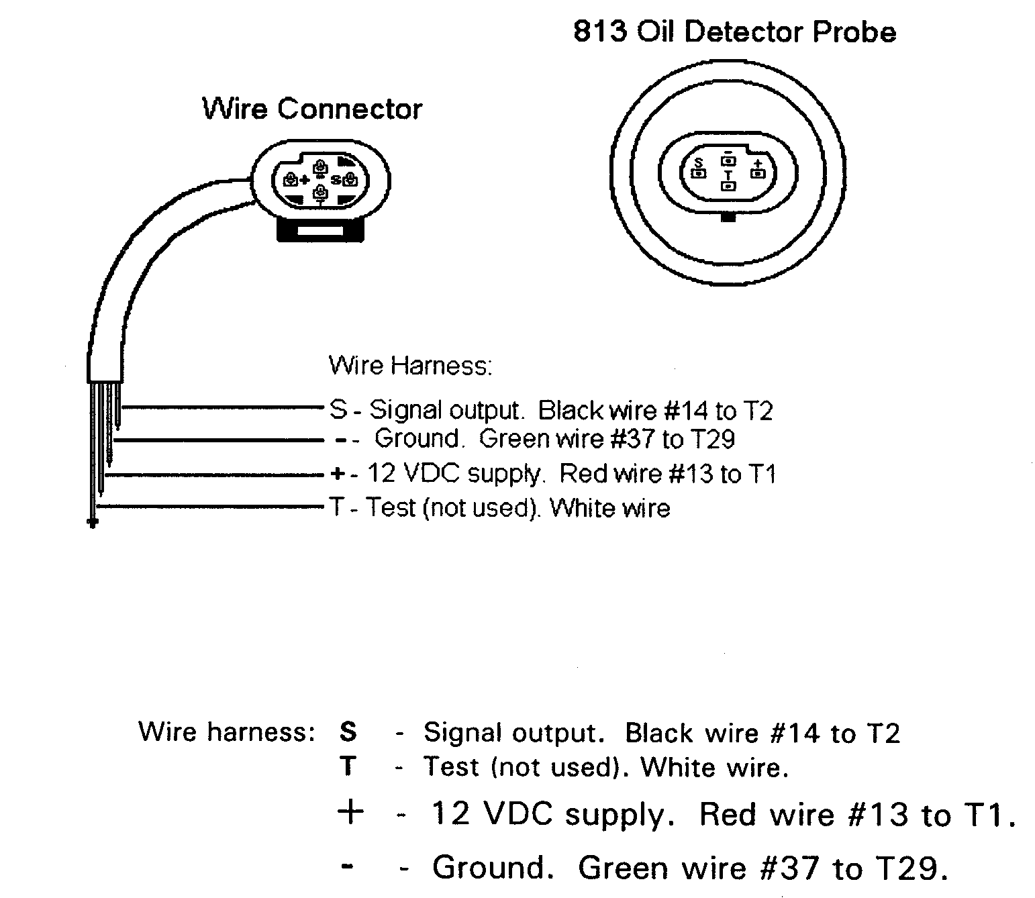 | To by-pass oil detector for testing wire harness and control circuitry:  - Turn Main Switch to "OFF" and disconnect power at the source.  - Disconnect the wire harness mating plug from the oil detector probe.  - Connect a jumper wire across the " + " and "S" terminals of the mating plug. A small wire or paper clip will work.  CAUTION: Do not allow the jumper wire to short to ground. Fuse 1 will open if a ground fault occurs.  - Remove fuses 2 & 3 to prevent the pumps from operating.  - Restore power and turn the main switch on ("HAND").  - The jumper wire allows the 12 VDC signal to by-pass the oil detector and the pump indicator lights should function and switch as in normal operation.  - Turn the main power switch to "OFF" and disconnect power at the source.  - Remove the jumper wire, reconnect the mating plug, and replace fuses 2 & 3 before continuing with normal operation.  NOTE: This test assumes the wire harness is connected properly to the control panel circuit board. Check the wiring schematic to be sure wires # 13, # 14 & #37 are connected correctly.  Contact your local distributor if you have questions.

4.4 Replacement Parts List

PART NUMBER | OLD  PART NUMBER | DESCRIPTION
BB00811DXX | 96609A | Bilge Boy™ 7.5 gpm 115VAC / 1Phase / 50 or 60 Hz
BB00822DXX | 96609B | Bilge Boy™ 7.5 gpm 230VAC / 1Phase / 50 or 60 Hz
391955588 | 99037K | Recommended Spare Parts Kit  (consists of one (1) each of the following: Q56875, Q79236, Q79235, Q62020, Q62046, Q62017, Q62178, Q59213, 88589A, Q59430, & Q229039)
391955688 | 99023K | Pump Kit  (consists of one (1) each of the following: Q56875, Q79236, Q79235)
391955788 | Q56875 or 99954A | Pump Impeller
391955888 | Q79236 | Pump Shaft Seal - Nitrile
391955988 | Q79235 | Pump Cover Gasket
391956088 | Q62020 or 99960A | 10 amp Fuse
391956188 | Q62046 or 99962A | 8 amp Fuse
391951288 | Q62017 or 99957A | ¾ amp Fuse
391951388 | Q62178 | Pump Indicator Lamp – Pre 1997 Production Units
391951488 | Q59213 | Pump Adapter O-Ring
391956288 | 88589A | Coalescer Filter Element
391956388 | Q59430 | Housing Cover Gasket
391951788 | Q229039 | Pump Indicator Lamp – 1997 and after Production Units
391956488 | Q152563 | Bilge Alarm Mounting Bracket
391951988 | Q229036 | 230 Volt AC Oil Pump Indicator Assembly
391952088 | Q229037 | 230 Volt AC Main Pump Indicator Assembly
391952188 | Q229040 | Mode Selector Switch
391952288 | Q229048 | 115 Volt AC Main Pump Indicator Assembly
391952388 | Q229049 | 115 Volt AC Oil Pump Indicator Assembly
391952488 | Q229051 | 115 VAC / 230 VAC Conversion Kit
391952588 | Q229201 or 99963A | Oil Detector Assembly
391952688 | Q61919 | Control Panel PC Board
391956588 | Q62198 | Pump Head (No Motor)
391956688 | Q61988 or 99956A | Pump Motor (No Pump Head)
391953088 | Q71156 | Differential Pressure Gauge
391953188 | Q78402 | 1/8” Female NPT Gauge Fitting
391956888 | Q78410 | 1” Male NPT Tube Fitting
391956988 | Q24892 | 1” Formed Tube (Gravity Separator Housing to Main Pump)
391957188 | Q78411 | ¾” Female NPT Tube Fitting
391953788 | Q69284 | ¾” Hose to ¾” NPT Fitting
391953888 | Q55040 | Decal Set (Inlet, Outlet, Drain)
391957288 | Q68825 | 1” NPT Elbow
391957388 | Q68829 | Pressure Relief Valve
391957488 | Q24893 | 1” Formed Tube (Main Pump to Coalescer Housing)

4.4 Replacement Parts List (continued)

PART NUMBER | OLD  PART NUMBER | DESCRIPTION
391957688 | Q229078 | Control Panel Box Assembly
391957788 | Q43839 | Nameplate
391957888 | Q68863 | 1” NPT x 8” long Nipple
391957988 | Q68824 | 1” NPT Check Valve
391958088 | Q613695 | Oil Return Line Assembly
391954888 | Q78395 | 1/8” NPT Male Connector
391958188 | Q68826 | 1” x 1” x ¾” NPT Reducing Tee
391958288 | Q68828 | 1” NPT Close Nipple
391955188 | Q43753 | Decal Set (Water, Oil, Main, Pump, Element)
391958388 | Q41177 | Service Manual
391958488 | Q68827 | ¾” x 1” NPT Reducing Bushing
391958588 | Q68893 | 3/8-16 x 1” long Street Elbow

Component Data

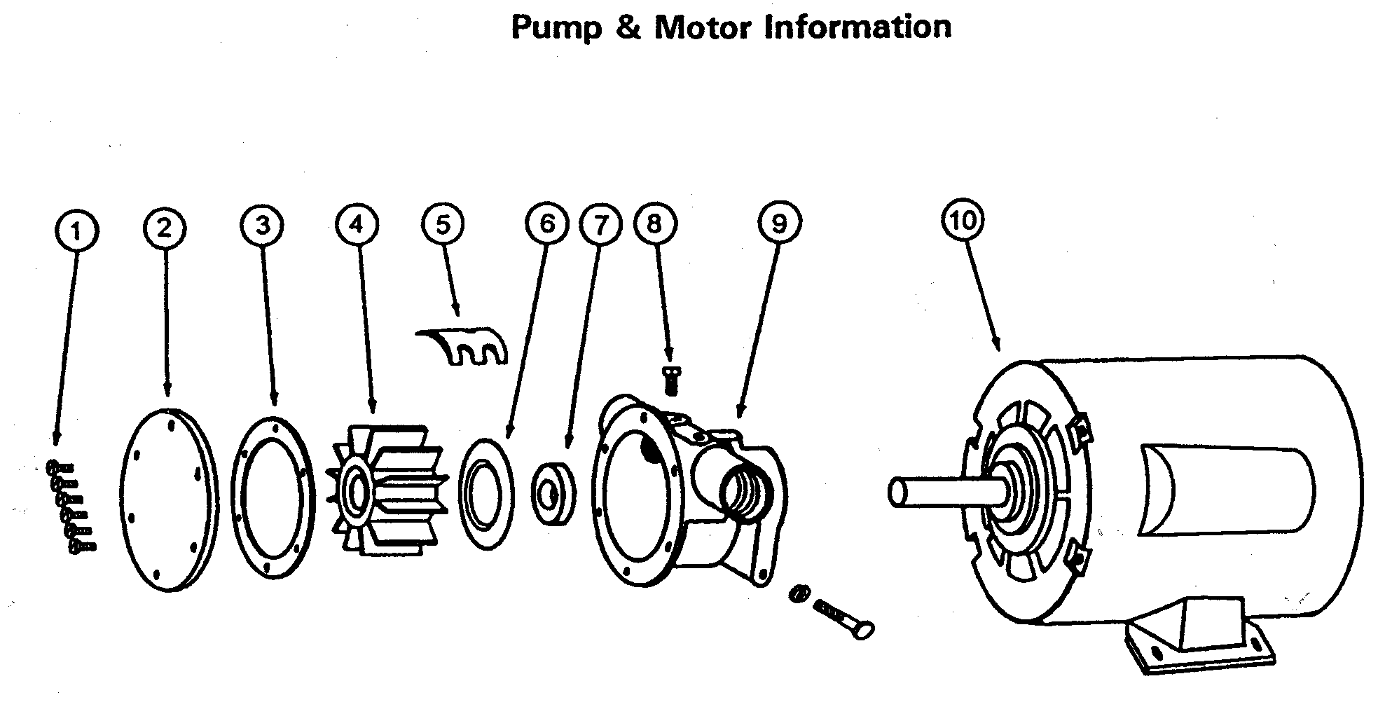

PUMP AND MOTOR SPARE PARTS

KEY # | DESCRIPTION |  | MFGR PART NUMBER | ST PART NUMBER
1 | Screw, End Cover Plate |  | 91002-0020 | N/A
2 | End Cover |  | 11830-0000 | N/A
3 | Gasket *** |  | 11816-0000 | 391955988
4 | Impeller *** |  | 5929-0003 | 391955788
5 | Cam |  | 490-0001 | N/A
6 | Wear Plate |  | 2235-0000 | N/A
7 | Seal *** |  | 92700-0420 | 391955888
8 | Cam Screw |  | 91003-0010 | N/A
9 | Body |  | 11814-0000 | N/A
10 | Motor |  | N/A | 391956688
N/A | Pump Head Assembly |  | 11818-003 | 391956588

NOTE: *** Means included in Pump Spare Parts Kit (ST P/N: 391955688)
MOTOR:

May be configured for:

1/3 Hp, 115 VAC, single phase, 60 Hertz, 1725 R.P.M., 50'C Ambient
1/3 Hp, 230 VAC, single phase, 50 Hertz, 1425 R.P.M., 50'C Ambient

Continuous duty, clockwise rotation, Totally Enclosed - Fan Cooled (TEFC), 6.2 amp max (115 VAC) 3 amp max (230VAC). Draw, 416 SS shaft, automatic thermal overload, split phase capacitor starting, sealed ball bearings, special urethane coating of all internal components, water drain holes, shaft seal to resist fluid penetration

PUMP:
Service Instructions:

- DISASSEMBLY

- Remove the end cover screws, end cover and gasket.

- Withdraw the impeller by pulling it straight out from pump body. (Install a new impeller and replace the cover, gasket and screws, or continue if replacement of the shaft seal is required.)

- Remove the wear plate with a screwdriver or hooked wire. (Replace if I worn or damaged.)

- Remove the cam and screw.

- Loosen the clamp bolt that holds the pump body to the motor.

- Disconnect the pump from the separator plumbing and loosen the motor mounting bolts.

NOTE: ONLY REMOVE THE PUMP FROM THE SEPARATOR PLUMBING IF SERVICE OF THE SHAFT SEAL IS REQUIRED. When servicing the MAIN PUMP loosen, but DO NOT REMOVE, the tubes attached at the bottom of the gravity separator and coalescer housings. This will assist the alignment and re-assembly.

CAUTION: The brass Swagelok (compression) tube fittings have a fine thread and are easily cross thread. Take extra care when aligning and reassembling them.

- Pull the pump body straight away from the motor to remove it.

NOTE: Observe the direction of the seal lip before removing it.

- Press the seal out of the seal cavity of the pump body.

- ASSEMBLY

- Press the new seal into the seal cavity of the pump body with the lip in the same direction as when removing the damaged one.

NOTE: Check the seal lip to be sure it will face the same direction as the old one'did before it was removed. (The lip should face the impeller bore of the pump.) A retainer is sometimes supplied with the replacement seal. Use of the retainer is not required.

- Lubricate the lip of the seal and the motor shaft, preferably with a silicone type grease.

- Install wear plate.

- Apply a gasket type sealant to the top of the cam and screw threads, and install the cam.

- Reattach the pump body to the motor.

CAUTION: Do not over tighten the clamp bolt.

- Place the pump & motor back into position & reconnect the separator plumbing to the pump.

CAUTION: The brass Swagelok (compression) tube fittings have a fine thread and are easily cross thread. Take extra care when aligning and reassembling them.

- Align the drive ding (inside the impeller sleeve) with the flat of the motor shaft, and gently push the impeller into the pump body, with a clockwise twisting motion. Compressing the impeller blades together will assist the assembly process. Do not damage the impeller blades - on the sharp edge of the cavity.

- Reassemble the cover, new gasket and cover screws to the pump body.

